Exercise-1

1. **Git Version**



1. **Config User ID and Email ID**

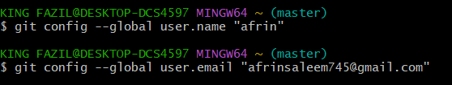

1. **Verification**

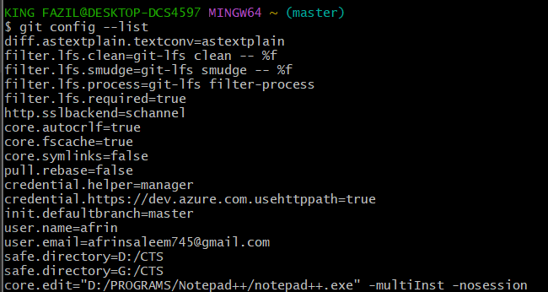

1. **Integrating Notepad ++ :**



1. **Verification of Integration :**

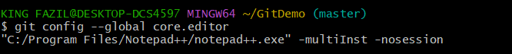

1. **create a new project “Demo” by executing the command**



1. **Git bash initializes the “Demo” repository. To verify, execute the command**

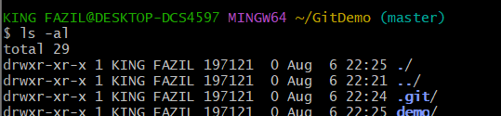

1. **To create a file “welcome.txt” and add content to the file, execute the command**



1. **To verify if the file “welcome.txt” is created, execute**

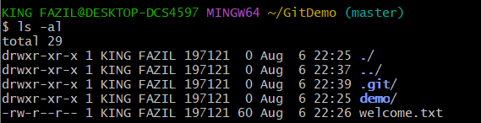

1. **To verify the content, execute the command**

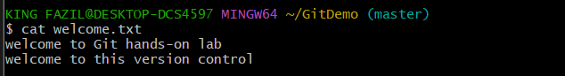

1. **Check the status by executing**

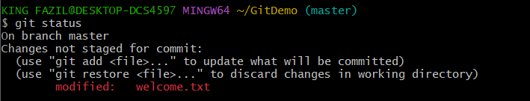

1. **To make the file to be tracked by Git repository, execute the command**



1. **To add multi line comments, we are opening default editor to comment. Execute the command**

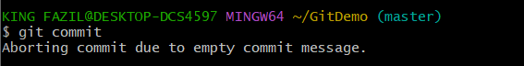

1. **Git status**

